The laboratory work 1

Exercise 1: Given two integer numbers return their product. If the product is greater than 1000, then return their sum.
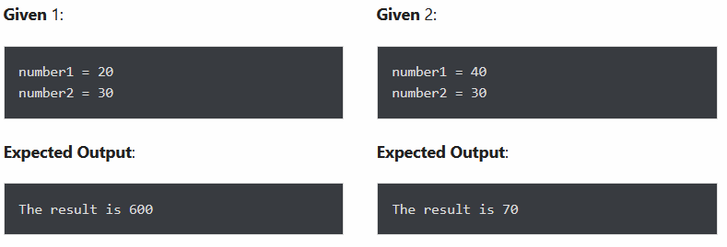

Exercise 2: Given a range of the first 10 numbers, iterate from the start number to the end number, and in each iteration print the sum of the current number and previous number.
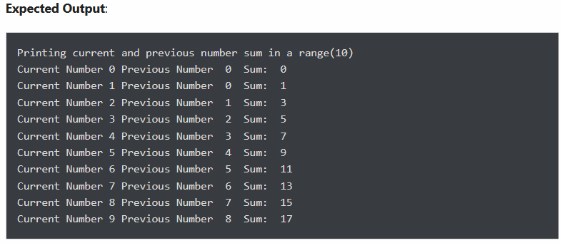

Exercise 3: Given a string, display only those characters which are present at an even index number.

Exercise 4: Given a string and an integer number n, remove characters from a string starting from zero up to n and return a new string.
For example, removeChars("pynative", 4) so output must be tive.

Exercise 5: Given a list of numbers, return True if first and last number of a list is same.
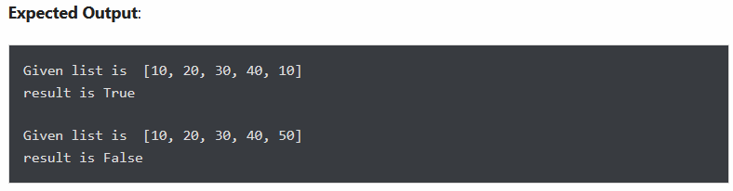

Exercise 6: Given a list of numbers, iterate it and print only those numbers which are divisible of 5.
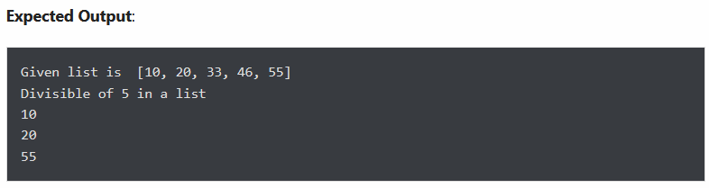

Exercise 7: Return the count of sub-string “Emma” appears in the given string.
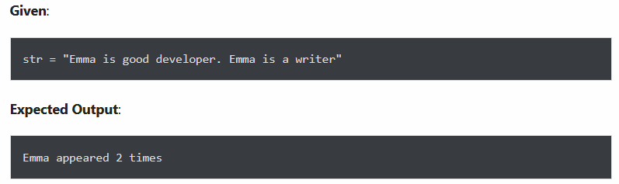

Exercise 8: Print the following pattern.

Exercise 9: Given a two list of numbers create a new list such that new list should contain only odd numbers from the first list and even numbers from the second list.
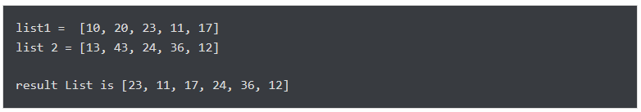

Exercise 10: Print downward Half-Pyramid Pattern with Star (asterisk)

